Parking Portal
By: Ezana Girmay

Girmay Ezana - System Specification - Parking Portal -v1
Systems Design 3150
Professor: Andy Cameron

June 6, 2024

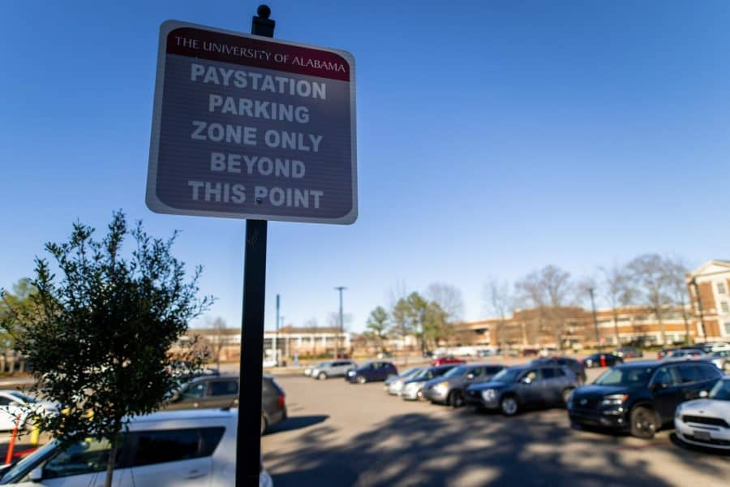
Table of Contents
1. Executive Summary 3
2. Introduction 4
2.1. Problem Statement / Project Vision 4
2.2. System Capabilities 4
2.3. Non-functional Requirements and Design Constraints 5
2.4. System Evolution 5
2.5. Document Outline 6
3. Structural Model 7
3.1. Model Introduction 7
3.2. Class Diagrams 7
3.3. Metadata 8
4. Architecture Design 20
4.1. Architecture Overview 20
4.2.1. Deployment Diagram 1 – Architecture Overview 20
4.2.2. Deployment Diagram 2 – Nodes and Artifacts 21
4.3. Hardware and Software Requirements 21
4.3.1. Hardware Components 21
4.3.2. Required Software Components 22
4.4. Security Plan 22
4.4.1. Security Overview 22
4.4.2. Security Plan 22
5. User-Interface 23
5.1. User-Interface Requirements and Constraints 23
5.2. Window/Screen Navigation Diagram 23
5.3. UI Wireframes 25
5.4. Reports: "Formal Output" Design 29
6. Appendices 30
6.1. Glossary 30
6.2. References / Bibliography 30
6.3. Supporting documentation 30

Executive Summary

The Client Problem
Seattle Pacific University (SPU) has 1,000s of students and staff members on campus most days. Because of this, it is often hard to find street parking, yet the parking lots owned by SPU are often nearly empty. Currently, SPU offers parking passes at hundreds of dollars per quarter, but seeing how empty the parking lots are, it's fair to say that few students use them. We believe this is because of the high cost and that most students are unwilling to spend so much money all at once.

The Project Solution
To solve this problem, Parking Portal plans to offer short-term parking to students. We believe students are more likely to take advantage of the parking lot if they only have to pay in small increments throughout the quarter instead of all at once at the beginning of the quarter. Our application, made only for SPU students, will allow students to enter their license plates and pay for a parking pass by the hour or for the whole day. By working with SPU, Parking Portal believes we can help them properly utilize their parking lots while earning them money.

Document
This document will outline Parking Portal and its features. This will include the app layout for our users, the class structure our software will follow, and our hardware and software requirements.

Introduction
Parking Portal is an application that plans to help fill the near-empty parking lots at Seattle Pacific University and generate money from their use. We plan to make an app that students can download on their phones that will allow them to buy hourly or daily passes for these lots. By offering students the ability to buy these passes quickly and conveniently, we can encourage more of them to use the parking lots rather than spend their time driving around trying to find parking on the streets. Our application will also allow users to look at their past purchase history and pay for any tickets issued to them. In order to allow users to be issued tickets through the app, we plan to integrate our application with the system The Office of Safety and Security is already using for ticketing. By using Parking Portal, SPU can better utilize its parking lots and generate profits from the sale of passes, while making parking easier for students.

Problem Statement / Project Vision
Seattle Pacific University has a big campus that is divided by many streets. Because of this, parking near your classes' buildings is convenient and necessary to make it to class on time. While some people solve this by buying a parking pass from the school, many choose not to, mainly because of the price of the passes. This lack of students buying parking passes also results in making it harder for students to find parking on the street. This leaves SPU with parking lots all over campus that are not being utilized to their full ability. In order to solve all these problems, we plan to build a parking app where students can pay for hourly and daily parking passes right on their phones. This allows us to capitalize on the parking lots while also giving students the chance to make parking easier.
To fully utilize SPU’s parking lots, we plan to build a mobile application that would allow SPU students to pay for parking on their phones. By offering parking passes for shorter periods of time and there for less money, we can remove any financial obstacles stopping students from using the parking lots. And by making payments as simple as possible, we can allow students to pay for a spot in seconds, encouraging anyone in a rush to use the parking lots in looking for parking.
While there are many approaches to solving these problems, we believe that Parking Portal is both the best and easiest, and one that benefits all shareholders involved. Obviously, the students are the ones who benefit the most from Parking Portal as they can now easily use the parking lots at far cheaper rates. But SPU also benefits from the sale of each parking pass as they now earn money from the lots instead of letting them sit there empty. And with our integration into The Office of Safety and Security's current ticketing system, their jobs will also be easier. The last shareholders to whom this will benefit are those living near SPU. Who no longer have so many cars parking around their homes, making it easier for them to find parking and less likely that someone will park in a way that blocks their driveway.

System Capabilities
Listed are the function requirements of the application and a brief description. The use case section numbers match up with the actual use cases in the system proposal. The functional requirement section includes functions that were not included in the use cases.

Use Case Diagram (Section 5.0 of System Proposal)
- 1. View purchase history – Allow users to see their past purchases.
- 2. Buy pass – Allow users to choose the pass they want and purchase it.
- 3. Send pass expired notification - Send a notification when the pass ends to the user asking them if they want to add time to their pass.
- 4. Look at issued tickets – Allow users to see tickets issued to them.
- 5. Pay ticket – Allow users to pay off tickets that have been issued to them.
- 6. Issue ticket – Allow lot managers to issue users tickets through the application.
- 7. Scan license plates in lots – The license plate scanner can check if cars in the lot have permission from a list of license plates that currently have a pass.
- 8. Generate Report – Allow individuals in the company to generate reports.
- 9. Add time to current pass – Allow users to add time to current passes.

Functional Requirements (Section 4.0 of System Proposal)
- 1. Register Account – Making a new account requires an SPU email so only students can use the application.
- 2. Buying Passes – Allow users to choose the pass they want and purchase it on the application.
- 3. Parking Pass Time – Display the time left on the purchased pass and send a notification to the user when the pass ends.
- 4. User History – Allow users to see their past purchases.
- 5. Tickets – Allow users to see tickets issued to them and pay off tickets that have not been paid off.

Non-functional Requirements and Design Constraints
Non-functional Requirements (Section 4.0 of System Proposal)
- Deployment Date – The application should be ready for deployment at the start of the school year to allow for the maximum chance that new users will download the app.
- Handwear requirements – The app should be compatible with Android and iOS hardware and older versions of both OS systems to ensure no user faces hardware restraints.
- Credit Card Security – To increase the security and safety of users' information, credit cards are only saved to the users' devices and not on our systems.

Design Constraints (Section 1.0 of System Proposal)
- Students only – Only students are allowed to register for an account by requiring an SPU email to make a new account on their phones.
- User interface (UI) Design – The user should be able to buy a pass in less than a minute, so a simple UI design is necessary.

System Evolution
After delivering the minimal viable product (MVP), Parking Portal has a few additional features we hope to add in future updates.

    - Version 2 Changes
After we have finished the MVP, Version 1, we have two new use cases to add to our application for Version 2. The first addition we plan to add to Parking Portal is allowing our users to buy Orca passes directly from the application. By doing this, we can simplify the process students currently must go through to get their discounted Orca cards. The second new function we plan to add to Parking Portal is the ability for students to find and offer carpools to each other. This will be a simple discussion board where students can post a request for a ride or offer for a ride. If they want to contact each other, they can request the poster’s SPU email to continue the conversation.

    - Version 3 and beyond Changes
We currently do not have plans for Version 3 of Parking Portal. As our users get the chance to use our application, we plan to collect feedback from them and make recommended changes to improve the app. This can include adding new features, changing UI designs, and any improvements they wish to see.

Document Outline
The remainder of this document is made up of 4 more sections (3.0–6.0) and contains 4 more diagrams. Section 3.0, Structural Model, has a class diagram that will show the basic class structure for the application. The next section, Architecture Design, will contain two diagrams, one for the architecture overview of Parking Portal and another for the nodes and artifacts. This section will also cover hardware and software requirements and the security plan. Section 5.0, user interface, will show the basic interface for Parking Portal with both the screen navigation and UI wireframes. The last section contains the glossary, references, and supporting documents.

Structural Model

Model Introduction
This section contains the class diagram showing the classes and their relationship in the Parking Portal. Variable names use the camel case format, while functions and classes have every word in the full name capitalized. All methods that do not have a return type listed return VOID. Following the class diagram, the metadata can be found, which goes into more detail about each class in the diagram.

Class Diagrams
Parking Portal Class Diagram made on Lucid Charts:
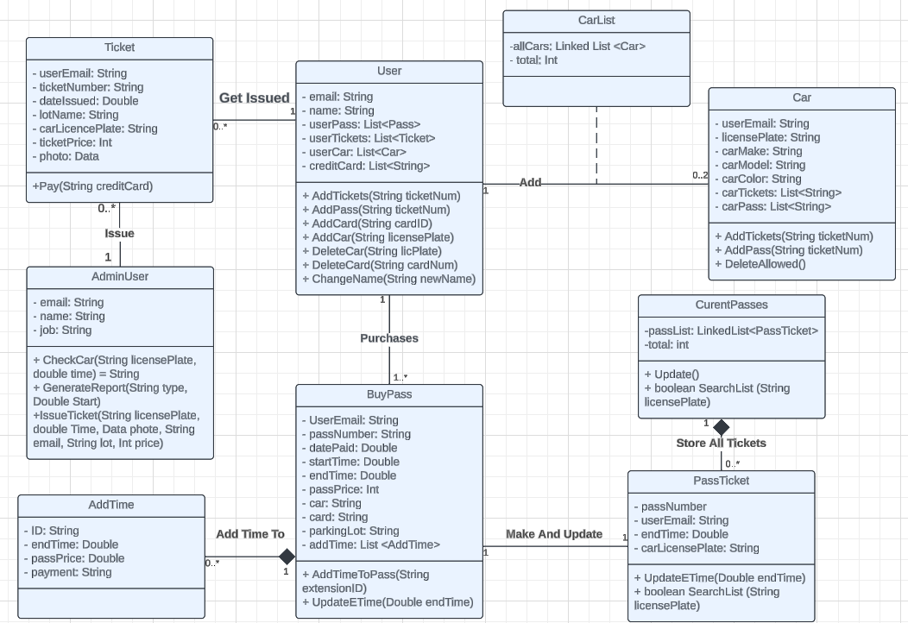

Class Diagram Lucid Chart Link: https://lucid.app/lucidchart/ef9de283-7287-4abf-864a-01ab46d9ea93/edit?invitationId=inv_dd3bc520-ac27-4191-a4e5-fb483d3417a2&page=0_0

Metadata

The next section contains the metadata for each class in the diagram and is ordered alphabetically. Each class contains details about its variables, methods, and visibility.

Class Diagrams – Table of Contents
- AddTime ………………………… 9
- AdminUser ……………………….10
- BuyPass …………………………..11
- Car ………………………………..12
- Carist ……………………………14
- CurrentPasses …………………….15
- PassTicket ………………………..16
- Tickets …………………………17
- User ……………………………18

AddTime

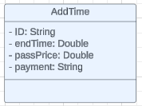
Description: Represents time added to previously purchased passes.
Visibility: Public
Is Abstract: No

Additional Information:
Attributes
Name | Description | Read Only? | Multiplicity
ID | Unique identification string. | Yes | 1
endTime | The new time the pass will expire at. | Yes | 1
passPrice | Price for the additional time. | Yes | 1
payment | Card number used for purchase. | Yes | 1

Operations
Name | Description | Is Query? | Is Polymorphic?

Processing Outlines

AdminUser
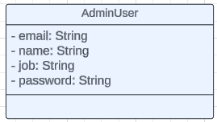

Description: Represents an employee at Parking Portal.
Visibility: Public
Is Abstract: No

Additional Information:
Attributes
Name | Description | Read Only? | Multiplicity
email | Email address assigned to account. | Yes | 1
name | Users Name. | Yes | 1
job | Job title of user. | Yes | 1
password | Account password. | No | 1

Operations
Name | Description | Is Query? | Is Polymorphic?

Processing Outlines

BuyPass
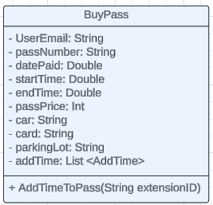

Description: Represents a pass bought by a user.
Visibility: Public
Is Abstract: No

Additional Information:
Attributes
Name | Description | Read Only? | Multiplicity
UserEmail | Email associated with user making purchase. | Yes | 1
passNumber | Unique identification string. | Yes | 1
datePaid | Date pass was purchased. | Yes | 1
startTime | Time pass becomes valid. | Yes | 1
endTime | Time pass is no longer valid. | Yes | 1
passPrice | Price of the pass. | Yes | 1
car | License plate that pass is valid for. | Yes | 1
card | Card used for purchase. | Yes | 1
parkingLot | Lot pass was purchased for. | Yes | 1
addTime | List of any extensions of the pass. | No | 0..*

Operations
Name | Description | Is Query? | Is Polymorphic?
AddTimeToPass | Adds am extension to the pass end time. | No | No

Processing Outlines

AddTimeToPass(String extensionID){
Take the ID string for AddTime class (extensionID) and store it in the addTime variable.
}
Car
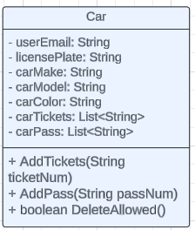

Description: Represents a car added to our system.
Visibility: Public
Is Abstract: No

Additional Information:
Attributes
Name | Description | Read Only? | Multiplicity
userEmail | Email associated with user making purchase. | Yes | 1
licensePlate | License plate of a car. | Yes | 1
carMake | Make of car. | Yes | 1
carModel | Model of car. | Yes | 1
carColor | Color of car. | Yes | 1
carTickets | Holds ticket ID of any tickets issued to car. | No | 0..*
carPass | Holds pass ID of any passes bought for the car. | No | 0..*

Operations
Name | Description | Is Query? | Is Polymorphic?
AddTickets | Adds a ticket ID to carTicket. | No
AddPass | Adds a pass ID to passTicket. | No
DeleteAllowed | Check car has no tickets. | Yes

Processing Outlines

AddTickets(String ticketNum){
Take the ID string for Ticket class (ticketNum) and store it in the carTicket variable.
}
AddPass(String ticketNum){
Take the ID string for BuyPass class (ticketNum) and store it in the carTicket variable.
}
DeleteAllowed(){
Check if carTicket is empty.
Return 1 if yes or 0 if not.
}

CarList
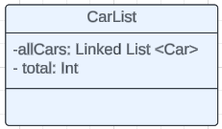
Description: Holds all the cars that have been added to the system.
Visibility: Public
Is Abstract: Yes

Additional Information:
Attributes
Name | Description | Read Only? | Multiplicity
allCars | Hold all cars in system. | No | 1
total | Number of cars in system. | N0 | 1

Operations
Name | Description | Is Query? | Is Polymorphic?

Processing Outlines

CurrentPasses
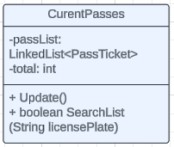

Description: Holds all passes that are active.
Visibility: Public
Is Abstract: Yes

Additional Information:
Attributes
Name | Description | Read Only? | Multiplicity
passList | Holds are passes that are currently active. | No | 0..*
total | Number of current passes. | No | 1

Operations
Name | Description | Is Query? | Is Polymorphic?
Update | Checks if there are any expired passes and deletes them from passList. | No | No
SearchList | Search if car currently has a pass. | Yes | No

Processing Outlines

Update(){
For loop every pass in passList.
Check each PassTicket’s end time.
If the pass is expired, delete it from passList.
If the end time is later than the current time, exit the list.
}
boolean SearchList (String licensePlate){
For loop every pass in passList.
Check each PassTicket’s car license plate.
If found, return 1; if not found, return 0.
}
PassTicket
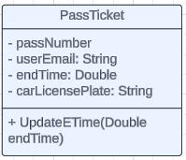

Description: Represents a pass that is currently active.
Visibility: Public
Is Abstract: No

Additional Information:
Attributes
Name | Description | Read Only? | Multiplicity
passNumber | ID for pass associated with. | Yes | 1
userEmail | Email associated with user making purchase. | Yes | 1
endTime | Time pass expires. | No | 1
carLicensePlate | License plate that pass is valid for. | Yes | 1

Operations
Name | Description | Is Query? | Is Polymorphic?
UpdateETime | Change the end time for pass. | No | No

Processing Outlines

UpdateETime(Double endTime){
New end time from AddTime class (endTime) replaces variable endTime.
Find its place in the list of passList classes.
Delete itself from the list.
For loop every pass in passList class after its old spot.
Check each PassTicket’s end time.
If the end time is later than its end time, add it before it in the list.
Else keep checking.
If list ends add to end of list
}
Tickets
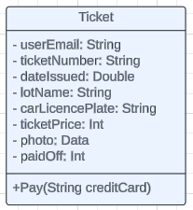

Description: Represents a ticket for a car parked on the lot without a pass.
Visibility: Public
Is Abstract: No

Additional Information:
Attributes
Name | Description |  | Read Only? | Multiplicity
userEmail |  | Email associated with user making purchase. | Yes | 1
ticketNumber |  | Unique identification string. | Yes | 1
dateIssued |  | Date ticket was issued | Yes | 1
lotName |  | Name of lot car was parked in. | Yes | 1
carLicencePlate |  | License plate for car getting ticketed. | Yes | 1
ticketPrice |  | Price of ticket. | Yes | 1
photo |  | Photo showing car parked in lot. | Yes | 1
paidOff |  | If ticket has been paid off. | No | 1

Operations
Name | Description | Is Query? | Is Polymorphic?
Pay | Pay ticket. | No | No

Processing Outlines
+Pay(String creditCard){
Charge card for the ticket amount.
Change paidOff from 0 to 1.
}

User
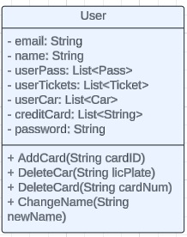

Description: Represents a customer account.
Visibility: Public
Is Abstract: No

Additional Information:
Attributes
Name | Description | Read Only? | Multiplicity
email | Email associated with user making purchase. | Yes | 1
name | Name of user | No | 1
userPass | Pass ID for all passes bought by user. | No | 0..*
userTickets | All ticketID issued to user. | No | 0..*
userCar | List of car license plates belong to user. | No | 0..2
creditCard | Credit cards save to user account. | No | 0..2
Password | Password fr user account. | No | 1

Operations
Name | Description | Is Query? | IsPolymorphic?
AddCard | Add credit card to user account. | No | No
DeleteCar | Delete car from user account and system. | No | No
DeleteCard | Delete card from user account. | No | No
ChangeName | Change name associated with user. | No | No

Processing Outlines

AddCard(String cardID) {
Add cardID to creditCard variable.
}

DeleteCar(String licPlate) {
Find car in the list of CarList class.
Check if it has tickets.
If no, delete it from CarList class
Remove from userCar variable.
}
DeleteCard(String cardNum) {
remove cardID to creditCard variable.
}
ChangeName(String newName) {
Delete value in variable name.
Add newname to variable name.
}

Architecture Design

Architecture Overview
This section contains the architecture diagram and the nodes and artifacts diagram. The architectural diagram gives a basic overview of the hardware. Parking Portal will be implementing a 3-tier client-server system. This will require the purchase of 3 web servers, an application server, and two database servers. The next diagram shows the software needed to use Parking Portal. Users can only access their accounts on their phones through our app. Management needs to download our application on their computers and then sign in to use our application. The license plate scanner scans cars in the parking lot and inputs their license plate into our system to check if they are allowed to park in the lot.

  - Infrastructure Model
    - Deployment Diagram 1 – Architecture Overview
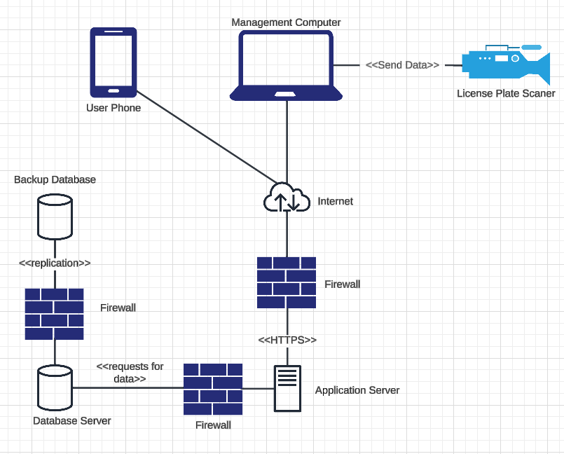
    - Deployment Diagram 2 – Nodes and Artifacts
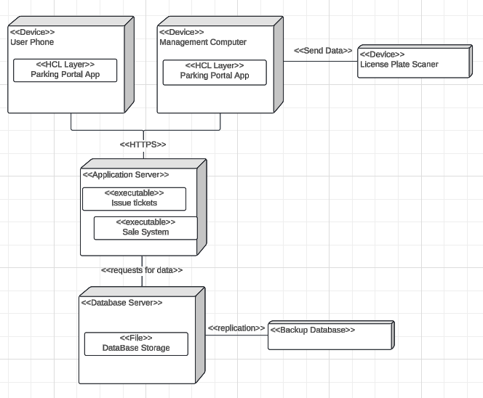

Hardware and Software Requirements
Parking Portal will be developed in a way that both limits any hardware restrictions for its users and on commonly used software. This approach will make it accessible to any user who wants to download the app and limit any additional spending the management team will have.

    - Hardware Components
No new hardware should be required to use Parking Portal. The users only need their phones, and management already has computers they can use. Management also already has a license plate scanner. All our servers will be on Amazon Web Servers (AWS), so we will not need to physically buy and install any.
- Server – Amazon Web Servers (AWS) will be used for all our server needs.
- Computers – Either a laptop or desktop running Android or iOS is needed. We will also make our app compatible with older-generation operating systems (OS) up to 2 years old.
- Phones – Phones running Android or iOS can be used. We will also make our app compatible with older-generation OS up to 2 years old.
- Scanner – Software will be intentionally made to be compatible with whatever scanner the school possesses
    - Required Software Components
In order to limit hardware restrictions, Parking Portal will be run on widely used software like iOS. We will also make our application compatible with older models.
- The software requirements for iOS are version 16 and up.
- For Android phones, version 13 or higher is required.
- We will use MySQL on AWS servers to manage our data.

Security Plan
    - Security Overview
To properly protect all assets, Parking Portal will implement security measures for the devices we run on and our servers. Parking Portal's first step in mitigating any security concerns is to collect and store only the data we need. Since our users are students, the school has all the relevant information we need on them, so we only store their emails and the names they give us. We also only store their credit card information on their devices. For our servers, AWS has both firewalls and encryption built in that we will be using. To help stop unauthorized access, we will implement a two-factor verification system for both users and management. We will also log out users periodically.

    - Security Plan
Table of threats and components showing which controls we will use to mitigate and respond:
Threats  Components | Disruption, Destruction, Disaster |  |  |  | Unauthorized Access |  | Files
Threats  Components | Fire | Flood | Power Loss | Circuit Failure | External Intruder | Internal Intruder | Corruption
Client Data | 1,2 | 1,2 | 1 | 1,2 | 3,4,6 | 6,7 | 1
Client device |  |  |  |  | 3,4,6,8 | 7 | 2
Management device | 1 | 1 | 1 | 1 | 3,4,6,8 | 6,7
Application Server | 1 | 1 | 1 | 1 | 3,4,5,6 | 3,6,7 | 1,2
Database Servers | 1,2 | 1,2 | 1 | 1,2 | 3,4,5,6 | 3,6,7 | 1,2

Controls
- Disaster Recovery Plan
- Backup database
- Two-factor verification
- Limit stored information
- Require SPU email
- Firewall
- Limit access to necessary data only
- Periodic force logout

User-Interface

User-Interface Requirements and Constraints
This section contains the screen navigator diagram and UI wireframes for Parking Portal. There are two screen navigator diagrams, one for the user app and another for the management app. For the user app, there are two home screens that will change based on whether the user currently has a pass or if they still need to buy one. The first of these is <<window>> Home Page, and after they buy a pass, it is <<Window>> Home Page With Pass. There are also two sets of UI wireframes for each screen navigator diagram.

Window/Screen Navigation Diagram
User app screen Navigation Diagram:
Management app screen Navigation Diagram:
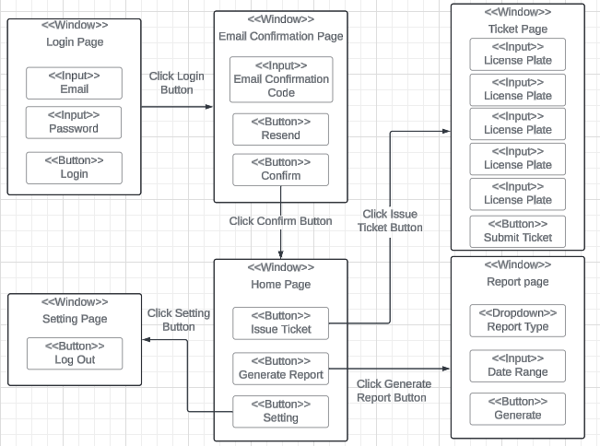

Link to Lucidchart screen Navigation Diagram and UI wireframes for user and management: https://lucid.app/lucidchart/ef9de283-7287-4abf-864a-01ab46d9ea93/edit?invitationId=inv_dd3bc520-ac27-4191-a4e5-fb483d3417a2&page=d8cH3M_bMjeb

UI Wireframes

UI Wireframes for user phone app:

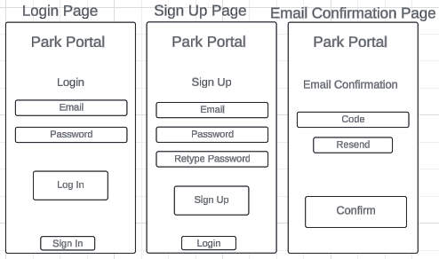

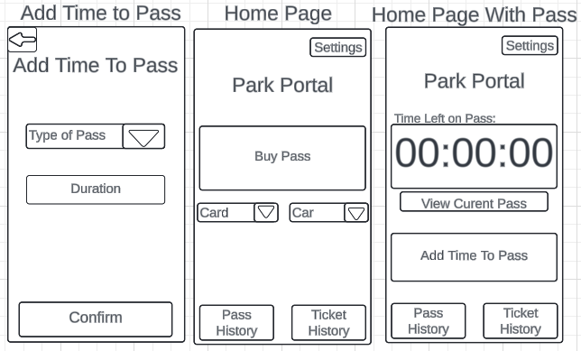
The Home Page and HomePage With Pass will automatically switch when you buy a pass and when it expires.

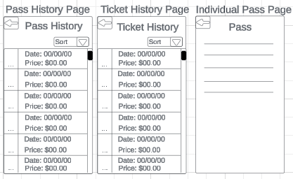
The Pass History Page and Ticket History Page will be scrollable if the amount exceeds the window size.
The Individual Pass Page will contain relevant information about the bought pass.
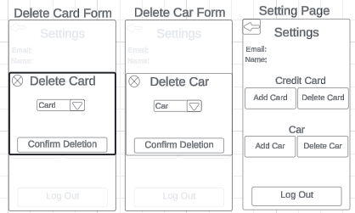
The Delete Card Form and Delete Car Form are both popup screens.

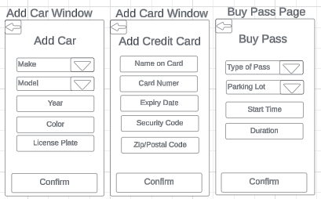
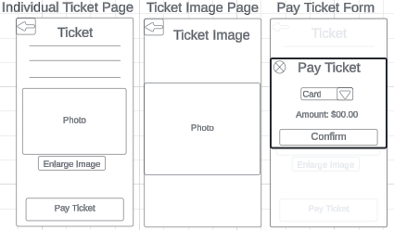

Management UI Wireframes for computers:
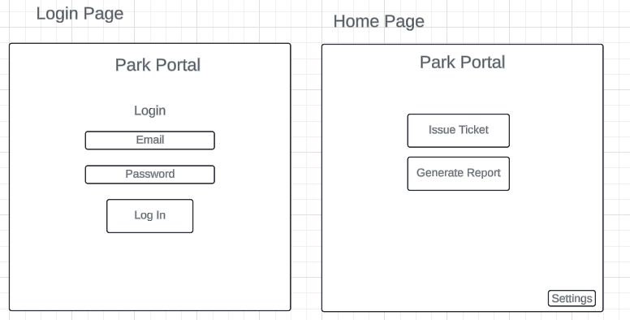
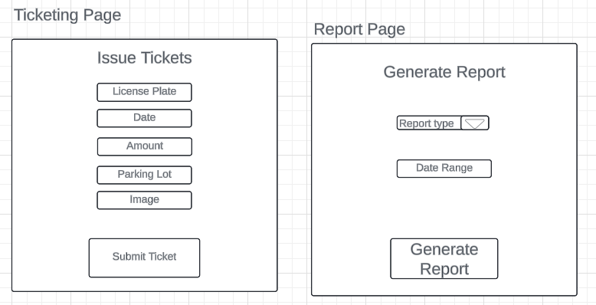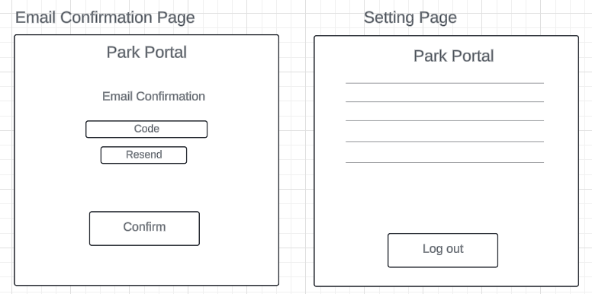
The Setting Page will contain information about the management user that is currently logged in on top and a log out button.

Reports: "Formal Output" Design
Parking Portal does not have any formal outputs. If the user wants any receipt or similar summary of the purchase, they can look at the Independent Ticketing Page, where they can find all relevant information about each pass. While management can create reports, they are built into the application and are not separate from the usual interaction output.

Appendices

Glossary
- Seattle Pacific University - SPU
- User interface - UI
- Minimal viable product - MVP
- Operating systems – OS
- Amazon Web Servers – AWS

References / Bibliography
Facebook, & Twitter. (n.d.). iOS: A Complete Version History. Lifewire. https://www.lifewire.com/ios-versions-4147730
Homepage | Lucid. (n.d.). Lucid.co. https://lucid.co/?_gl=1
Larman, C. (2002). Applying UML and patterns : an introduction to object-oriented analysis and design and the unified process. Prentice Hall Ptr.
Raphael, J. (2024, April 26). Android versions: A living history from 1.0 to 14. Computerworld. https://www.computerworld.com/article/1714347/android-versions-a-living-history-from-1-0-to-today.html

Supporting documentation
N/A

